https://www.safe.land/se/grannsamverkan/
Detta är en gratis APP som man frivilligt kan ansluta sig till!
Är det något för oss inom BRF Danska vägen?

This app is only available on the App Store for iOS devices.
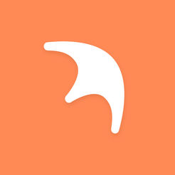

Safeland (formerly Trygve) 12+

Connecting communites

United Eyes AB

  - Free

iPhone Screenshots
- 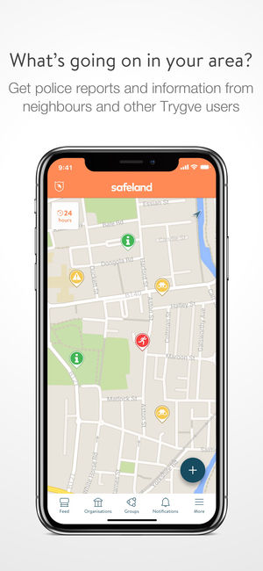
- 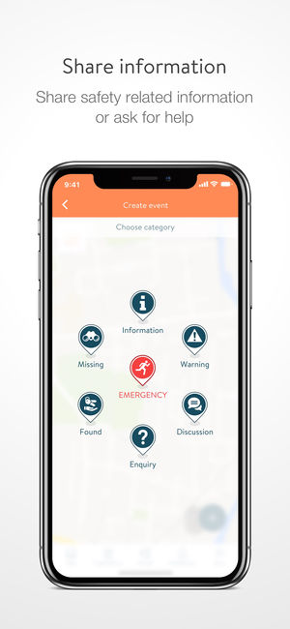
- 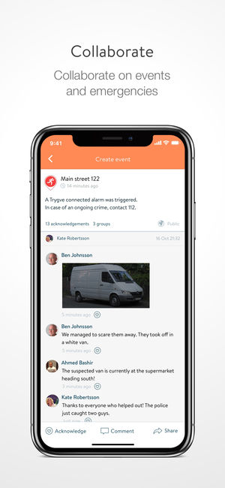
- 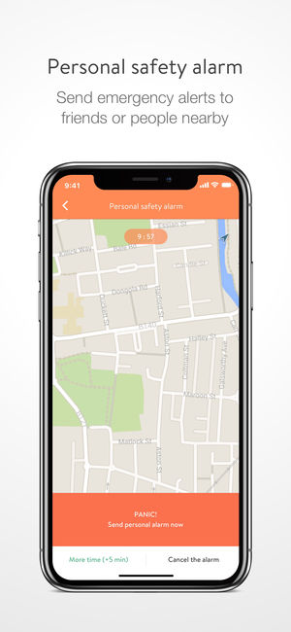
- 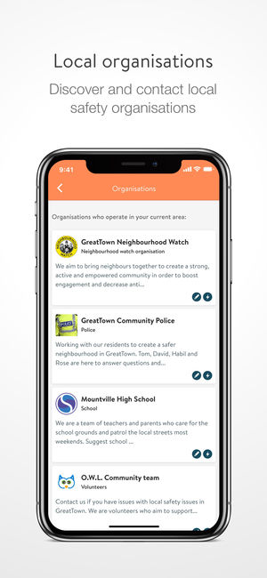

Description
Safeland is an award-winning, free digital tool that brings communities together to build a stronger, safer society.
Safeland creates an online ‘Neighbourhood Watch’, making your local community safer and more secure through a variety of exciting features.
Users can share and receive local incident information in real time, by real people. Safeland also provides a personal safety alarm, so users can notify their groups or nearby public that they need immediate assistance. In certain coun

